\

**Report of FFHPCTA the Fiscal Year 2024 Semi-Annual Performance Review Meeting for Sub-Grants**

May 30-31, 2024 ishdoeth.org | info@ishdoeth.org



**ISHDO**

Integrated Service on Health and Development Organization

**USAID PEPFAR**

­­­

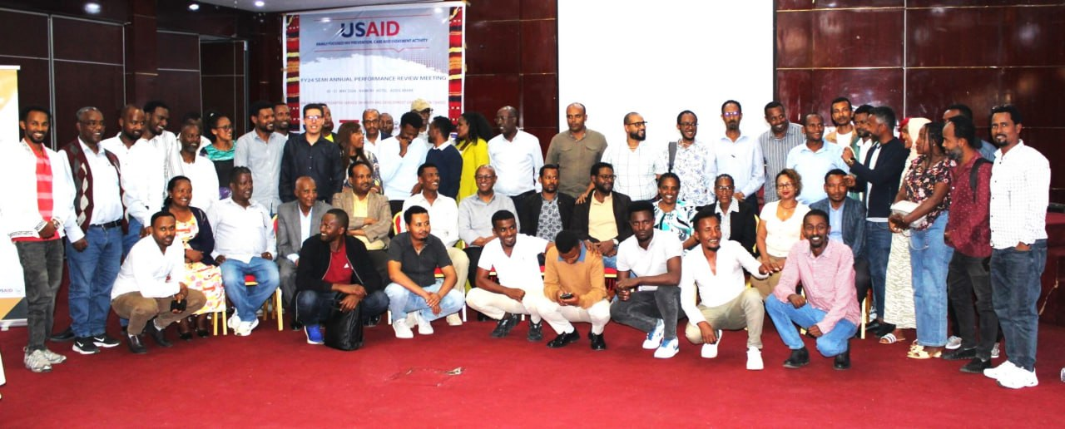

**Date:** May 30-31, 2024,

**Place:** Harmony Hotel, Addis Ababa, Ethiopia

**Organized by:** Integrated Service on Health and Development Organization (ISHDO)

**Donor:** USAID PEPFAR

Table of Contents

Acknowledgements 3

Abstract 4

Meeting agenda 4

Participants 5

Meeting Agendas in detail 7

Well Coming Address and Key Notes 7

FY 24 SAPR Sub grants performance presentation 8

Best practices Presentation on IPTG in case of MENA 9

Pediatric case identification with MOH, ORHB case identification team and FIDO 9

Adolescent DSDM implementation challenges and success panel discussion in case of MENA and ADA Experience 10

National HIV Revised Strategic Plan- CSO Priority areas 10

Demonstration and Testimony from IMPower how to keep our selves Safer 11

Findings of Positive Verification at Oromia selected sites and lessons Learned 11

Complains issues in case of Grant and Complains 11

Summary of JISS and RDQA Findings 12

Progress of FY 24 Q3 and Focus areas to close the gaps in case of OVC, CHCT and M&E 12

Action points and way forwards 13

Closing Remark 15

***Meeting Agenda and Highlights:***

ISHDO | ishdoeth.org

*1. Welcome Address and Key Notes:*

*- The agenda was reviewed and finalized with input from technical teams.*

*2. FY 24 SPAR Performance Presentation:*

*- Performance metrics and progress of the fiscal year were discussed.*

*3. Best Practices Presentation on IPG in MENA:*

*- Focused on Integrated Project Governance best practices within the MENA region.*

*4. Pediatric Case Identification:*

*- Collaboration efforts with the Ministry of Health and regional health bureaus for identifying pediatric HIV cases.*

*5. Adolescent DSDM Implementation Challenges:*

*- Addressed the implementation challenges in Differentiated Service Delivery Models (DSDM) for adolescents.*

*This semi-annual meeting underscored the commitment to enhancing HIV prevention, care, and treatment activities through collaborative efforts and continuous performance reviews, ensuring the alignment with USAID PEPFAR's goals*

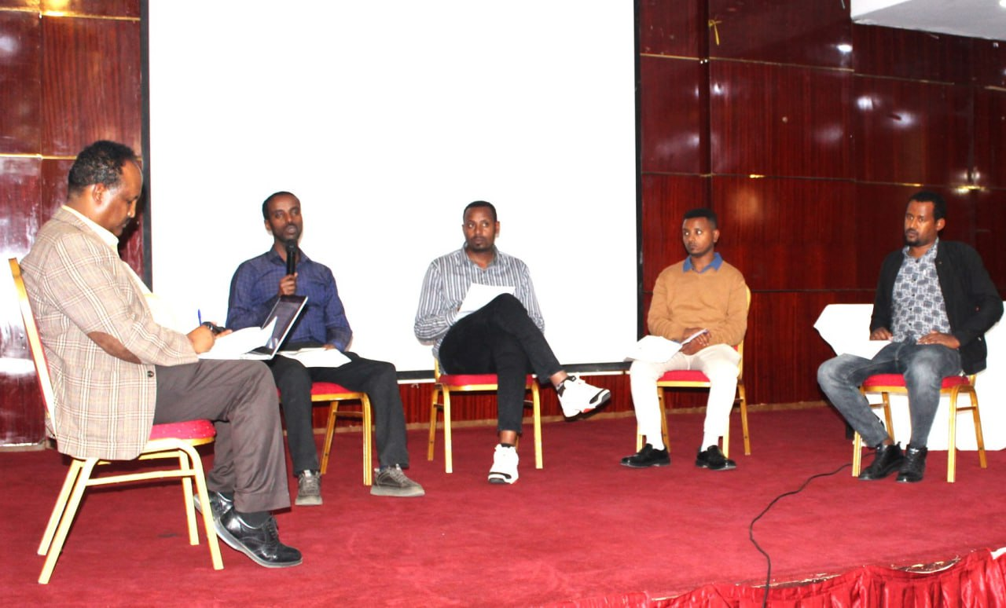

*Other notable contributions came from representatives of the Federal Ministry of Health, regional health bureaus, and partner organizations such as Project Hope, FHI 360, and several Ethiopian development associations*

***Executive Summary of the Report***

***Title****: Report of FFHPCTA Fiscal Year 2024 Semi-Annual Performance Review Meeting for Sub-Grants*

***Date****: May 30-31, 2024*

***Location:*** *Harmony Hotel, Addis Ababa, Ethiopia*

***Organized by****: Integrated Service on Health and Development Organization (ISHDO)*

***Donor:*** *USAID PEPFAR*

***Acknowledgments:***

*The meeting, organized by ISHDO's Prime Family Focused HIV Prevention, Care, and Treatment Activity (FFHPCTA) and funded by PEPFAR through USAID, saw contributions from various participants and organizations. Key acknowledgments include:*

*- Mr. Aklilu Nega (ISHDO Executive Director) for the welcoming address*

*- Mr. Tsegaye Tilahun (USAID Agreement Officer) for closing remarks*

*- Dr. Girmachew Mamo (FFHPCTA Chief of Party) for leading the agenda and presentations*

**Acknowledgments**

The meeting was hosted by ISHDO's Prime Family Focused HIV Prevention, Care, and Treatment Activity (FFHPCTA) with financial assistance from PEPFAR through USAID. We extend our gratitude to USAID PEPFAR and all participants who contributed to the meeting’s success, especially Mr. Aklilu Nega, ISHDO Executive Director, for his welcoming address, and Mr. Tsegaye Tilahun, USAID Agreement Officer, for his closing remarks.

Special thanks to Dr. Girmachew Mamo, FFHPCTA Chief of Party, for drafting the agenda and leading the presentations, as well as Dr. Peteros Mitiku, Mr. Dereje Ketema, Mr. Admas Terefe, Mr. Abel Ahmed, Mr. Tesfaye Demissie, Ms. Selam Bekele, Mr. Minase Tesfaye, and Mr. Dawit Haile for their contributions. We also thank delegates from the Federal Ministry of Health, Oromia Regional Health Bureau, Oromia Bureau of Labor and Social Affairs, Oromia Education Bureau, Gambella Regional Health Bureau, Project Hope, FHI 360, Mekdim Ethiopia (MENA), Amhara Development Association (ADA), Organization for Development Association (ODA), FIDO, and LIAE.

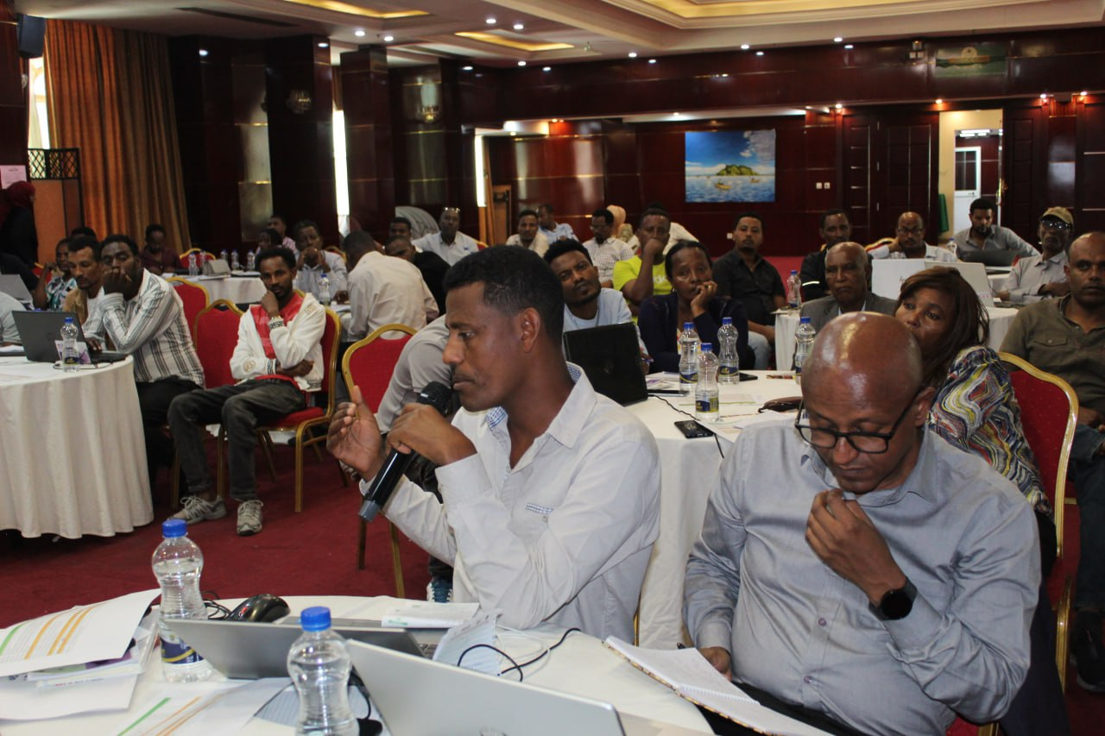

**Meeting Agenda:**

1. **Welcome Address and Key Notes**
   * The meeting agenda has been shared with participants in advance.
   * Technical teams have reviewed and provided feedback on the agenda.
   * Finalized agenda for the meeting.
2. **FY 24 SPAR Performance Presentation**
3. **Best Practices Presentation on IPG in MENA**
   * Discussing best practices related to IPG (Integrated Project Governance) in the MENA region.
4. **Pediatric Case Identification**
   * Collaboration with the Ministry of Health (MOH), ORHB case identification team, and FIDO.
   * Focus on identifying pediatric cases.
5. **Adolescent DSDM Implementation Challenges and Success Panel Discussion**
   * Sharing experiences from the MENA and ADA regions.
   * Discussing challenges and successful implementation of the DSDM (Data Science and Decision Making) approach.
6. **National HIV Revised Strategic Plan: CSO Priority Areas**
7. **Demonstration and Testimony from IMPower**
   * Learning how to keep ourselves safer.
8. **Primary HIV and Violence Prevention**
   * Panel discussion involving the Board of Health (BOH), Board of Education (BOE), School Management, Woreda Education Office, and partners.
   * Exploring ways to ensure sustainability.
9. **Findings of Positive Verification @ Oromia Selected Sites**
   * Lessons learned from the verification process.
10. **JISS and RDQA Findings**
    * Reviewing findings related to Joint Internal Security Systems (JISS) and Regulatory Data Quality Assessment (RDQA).
11. **Complaints Issues in Case of Grant and Complaints**
12. **Progress of FY 24 Q3 and Focus Areas**
    * Closing gaps in areas related to Orphans and Vulnerable Children (OVC), Community Health and Care Teams (CHCT), and Monitoring & Evaluation (M&E).
13. **Way Forwards and Action Points**

# Participants

The total number of participants of the meeting were 71 among the estimated participants that were planned to be 82 which is summarized as follows by the table

|  |  |  |  |
| --- | --- | --- | --- |
| Participants | Planned participants | Available participants | % |
| USAI Delegates | 1 | 1 | 100 |
| ISHDO Prime Senior management Team (Executive Director, Chief of Party and Admin and program staff from Central and Cluster Teams | 14 | 14 | 100 |
| **TA partners delegates** |  |  |  |
| FHI 360 | 1 | 1 | 100 |
| Project Hope | 3 | 3 | 100 |
| **Prime Partners delegates** |  |  |  |
| ADA | 3 | 1 | 33 |
| Mary Joy Ethiopia | 3 | 1 | 33 |
| MENA | 3 | 3 | 100 |
| **Sub grants Administrative and program staffs** |  |  |  |
| DUGDA | 6 | 6 | 100 |
| FIDO | 6 | 4 | 66 |
| HUNDEE | 6 | 5 | 83 |
| MENA | 6 | 6 | 100 |
| NTCBCA | 6 | 6 | 100 |
| ODA | 6 | 5 | 83 |
| LIAE | 6 | 6 | 100 |
| Government officials delegate |  |  |  |
| Federal Ministry of Health delegate (FMOH) | 3 | 3 | 100 |
| ORHB delegates | 3 | 3 | 100 |
| OEB delegates | 1 | 1 | 100 |
| BOLSA | 1 | 1 | 100 |
| Gambella regional Health Beruae Delegate | 1 | 1 | 100 |
| Total | 82 | 71 | 86 |

**Mr. Ogetu Adinge’s Appreciation**

Mr. Ogetu Adinge, the head of Gambella Regional Health Bureau, praised ISHDO for its partnership with LIAE in Gambella. He emphasized the need for increased efforts in Gambella due to the region’s high HIV prevalence.

**Dr. Gusha Balako’s Keynote Address**

Dr. Gusha Balako, Deputy Head of ORHB, acknowledged ISHDO and its partners’ achievements in the region. He urged a focus on the following key areas:

* Strengthening collaboration between communities and health facilities.
* Maintaining the first 95 (testing), second 95 (treatment), and third 95 (viral suppression) goals.
* Creating demand for health services.
* Ensuring equity and sustainability with quality health services.

# Meeting Agendas in detail

## Well Coming Address and Key Notes

The meeting commenced with Dr. Girmachew Mamo, the FFHPCTA Chief of Party, serving as the moderator. Dr. Girmachew opened the floor for welcoming remarks and keynotes from distinguished guests

**Mr. Aklilu Nega’s Address**

Mr. Aklilu Nega extended a warm welcome to all esteemed guests, including USAID delegates, the Deputy Head of Oromia Regional Health Bureau, Dr. Gusha Balako, the Head of Gambella Regional Health Bureau, Mr. Ogetu Adinge, FMOH delegates, TA partners, prime partners, sub-grantees, BOLSA representatives, education bureau delegates, and ISHDO administrative and program staff. He expressed excitement at seeing familiar faces who have been part of the journey of HIV epidemic control. Mr. Aklilu emphasized the importance of strengthening local partnerships in combating HIV.

.

**Mr. Fekadu Yadeta’s Keynote Address**

Mr. Fekadu Yadeta, an FMOH delegate, commended community partners for their role in establishing an AIDS-free Ethiopia. He emphasized the need to:

* Refer to the National Strategic Plan Spectrum.
* Improve performance.
* Prioritize prevention of mother-to-child transmission (PMCT).
* Strengthen the 3Cs (Care, Cure, and Control) approach.
* Focus on behavioral change and HIV prevention.

Following the keynote addresses, Dr. Girmachew facilitated participant self-introductions to foster mutual understanding.

Key highlights from the presentation:

* Positive Trends: Most MER and Custom indicators are on track, except for HIV self-tests (at 39% of the semiannual target).
* OVC Graduation SAPR: Some sub-grantees (HUNDEE, MENA, NTCBCA, and ODA) need to address performance gaps for OVC graduation.
* CDSDM Performance: DUGDA and LIAE are low performers; they must accelerate efforts.
* Data Entry Gap: Real-time data entry needs improvement.

## 

## FY 24 SAPR Sub grants performance presentation

Mr. Abel Ahemed delivered the FY24 SAPR performance presentation. The content covered various aspects, including:

Geographical Implementation Areas Coverage: The FFHPCTA’s reach across different regions

Project Profile: An overview of the project’s objectives and scope.

SAPR Performance of MER and Custom Indicators: Overall progress in meeting targets.

Performance by Sub-Grantees: How different partners are contributing.

COVID-19 Demand Creation: Efforts related to pandemic response.

Financial Performance: Financial aspects of the project.

Challenges and Way Forward: Identifying obstacles and proposed solutions.

* Asset Transfer: LIAE’s performance in asset transfer is suboptimal.
* Challenges: Test kit shortages, 3C structure turnover, and other issues.
* Discussion and Clarity: Participants raised questions, including the need for 3C establishment in Gambella and strengthening it in Oromia. Challenges related to smartphone use for bidirectional referral, care and support, facility-community collaboration, test kit utilization, PMCT, pediatric case finding, and real-time data entry were addressed by technical experts.

Overall, the presentation facilitated meaningful discussions, and consensus was reached on suggested ideas.

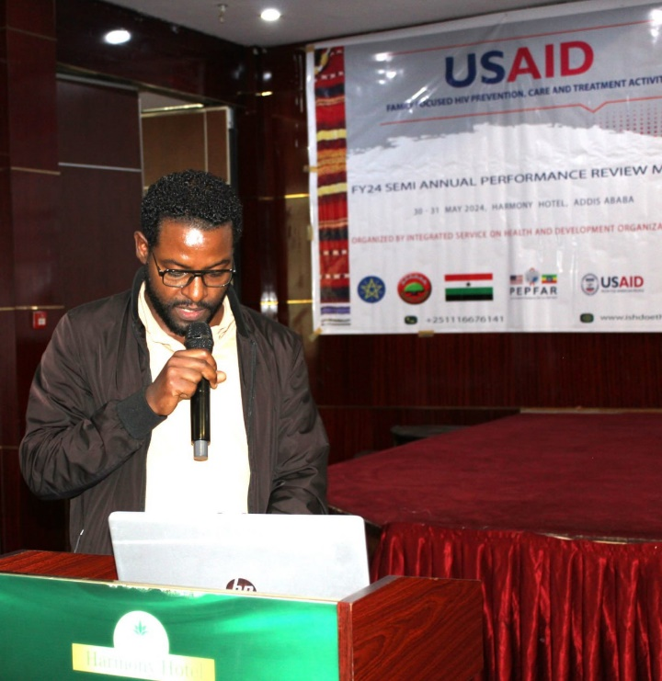

## Best practices Presentation on IPTG in case of MENA

**MENA’s Experience with Interpersonal Psychotherapy Groups (IPTG)**

MENA’s journey with IPTG encompasses several critical aspects:

Group Formation and Duration: MENA actively formed IPTG groups and ensured their sustained duration.

Importance of Partnerships: Collaborations with health facilities (HFs), Project Hope, ISHDO, and religious leaders played a pivotal role.

Key Lessons Learned:

* + Creating a safe environment to combat stigma and discrimination.
  + Maintaining a flexible schedule for participants.
  + Regular follow-up to monitor progress.

Challenges Faced by MENA during IPTG implementation:

* + Addressing stigma related to mental health and HIV.

Managing extensive paperwork and data encoding.

**Unique Implementation Approaches**:

* + MENA adopted a flexible schedule.
  + Budget reallocation for refreshments.
  + Innovative data tracking using wall-mounted visual aids (tally sheets).

**Sustainability and Adaptability**:

* + Community engagement through PLHIV associations.
  + Capacity building.
  + Continuous improvement and adaptation.

MENA’s commitment to these principles ensures effective IPTG implementation.

## Pediatric case identification with MOH, ORHB case identification team, and FIDO

**Pediatric Case Identification Panel Discussion**

Dr. Petros facilitated a panel discussion on pediatric case identification. The panelists included representatives from the Ministry of Health (MOH), the Oromia Regional Health Bureau (ORHB) case identification team, and FIDO. Challenges related to pediatric case finding and linkage to treatment were thoroughly discussed. Key strategies to enhance Pediatric Index Case Testing were identified:

* Line Lists: Creating comprehensive lists of potential pediatric cases.
* Risk Assessments: Evaluating risk factors for targeted testing.
* Integration with PMCT Team: Collaborating with Prevention of Mother-to-Child Transmission (PMCT) teams.
* Support Groups and Demand Creation: Utilizing support groups and other modalities to increase awareness and demand.

The challenges highlighted included:

* Community Empowerment: Addressing gaps in community involvement.
* Weak PMCT and Town-Level Health Facility Collaboration: Strengthening these areas.

Tailored communication, awareness campaigns, and advocacy efforts are crucial to overcome these challenges.

Adolescent DSDM Implementation Panel Discussion (MENA and ADA Experience)

Under the guidance of Mr. Deereje Ketema, a panel discussion on Adolescent Differentiated Service Delivery Models (DSDM) was held. Notable achievements included adapting this initiative at the community level and implementing refills. However, engaging with ASK US (a specific group) Changed the initiative. Participants recommended integrating AYDSDM into regular plans and sustaining it within the community without ASK US involvement. Project Hope received an assignment to strengthen AYDSDM. Key takeaways from the panelists’ experiences encompassed Sensitization Workshops, Task Sharing, Session Observation, Displaying Joint Review Meetings, and integrating Mental Health Screening as a Best Practice.

## National HIV Revised Strategic Plan- CSO Priority areas

**National HIV Revised Strategic Plan: CSO Priority Areas**

Mr. Habtamu Kassa, representing the Ministry of Health (FMOH), led the session on the National Revised HIV Strategy. The presentation highlighted the following key points:

Overall National Goal: The strategy aims to combat HIV/AIDS effectively at the national level.

Strategic Objectives:

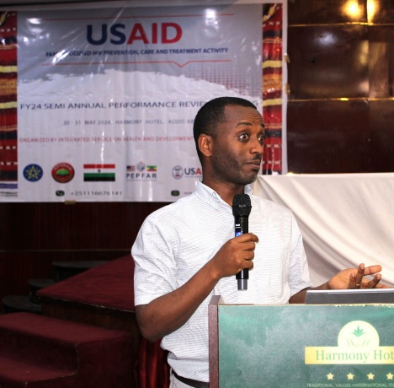

**National HIV Revised Strategic Plan: CSO Priority Areas**

Mr. Habtamu Kassa, representing the Ministry of Health (FMOH), led the session on the National Revised HIV Strategy. The presentation highlighted the following key points:

Overall National Goal: The strategy aims to combat HIV/AIDS effectively at the national level.

Strategic Objectives:

* + Addressing the epidemiology of HIV/AIDS.
  + Strengthening community-level interventions.
  + Achieving the triple 95 goals (testing, treatment, and viral suppression).

Focus Areas:

* + Building the capacity of CSOs (Civil Society Organizations), CBOs (Community-Based Organizations), and FBOs (Faith-Based Organizations).
  + Increasing community engagement.
  + Facilitating information sharing.

Mobilizing resources.

Mr. Habtamu emphasized these strategic objectives to enhance the fight against HIV/AIDS.

## Demonstration and Testimony from IMPower on how to keep ourselves Safer

**Mpower Trainees’ Testimony on Sexual Violence Prevention**

Under the guidance of the ODA team, two Mpower trainees shared their experiences. They demonstrated three types of sexual violence prevention strategies: physical, verbal, and vocal. The participants were deeply impressed by the stage performance and effective tactics employed by these trained girls.

During the subsequent discussion on primary HIV and violence prevention, stakeholders emphasized the need for sustainability. The educational office and other relevant parties suggested that local government structures, including schools and government stakeholders, should take over the intervention to ensure its continuity.

## Findings of Positive Verification at Oromia selected sites and lessons Learned

HIV-positive verification findings were presented for 225 individuals who underwent assessment, with 198 (88%) of them being fully linked. However, in the case of Assela and Shenen Gibe, 5 HIV clients were rejected, and in Bishoftu, 8 positively identified clients were also rejected. The key challenges discussed included inconsistent understanding of the positive tracking code, differences in UART numbers, low engagement of community partners, and a lack of Memoranda of Understanding (MOUs) with health facilities.

As a solution, it was proposed to standardize the documentation of community entry in the positive tracking register, establish a uniform coding system, and address knowledge gaps. Dr. Petros and his team were granted permission to resolve the coding issues, which had been a source of conflict between the community and facility partners.

# Complains issues in case of Grant and Complains

The other issue discussed pertained to grant and compliance matters. While most partners are performing well, there are a few exceptions. For instance, travel requests have been consistently high, and compliance issues have been related to NTCBCA. The following focus areas were suggested to address these challenges: requesting VAT reimbursement, obtaining prior approval for any payments, and adhering to USAID’s financial rules and regulations.

ISHDO emphasized that it will terminate partnerships with partners failing to comply with USAID and ISHDO expense policies. The internal controlling system was also identified as a weakness across all partners except MENA. As a solution, sub-grants are expected to help control their internal budgets.

## Summary of JISS and RDQA Findings

The summary of JISS and RDQA findings was also presented for HUNDEE, DUGDA, ODA, FIDO, and LIAE. Common gaps shared across these areas include documentation challenges related to GBV, CALHIV, and schools, as well as weak supervision plans and referral systems. Specifically, in the case of FIDO, the lack of trained CEFs due to their promotion posed a challenge, and FIDO was advised not to promote CEFs without proper training. For RDQA, key challenges include inconsistent data entry, incomplete reporting services, and a lack of data capturing system in Com-care for ES activities. As a way forward, real-time data entry and regular RDQA were suggested.

## Progress of FY 24 Q3 and Focus areas to close the gaps in case of OVC, CHCT, and M&E

**In the case of OVC FY 24 Q3 Focus areas are: -**

- Strengthen service quality for Orphans and Vulnerable Children (OVCs) and Caregivers (CGs).

* Address the graduation process for LIAE (Local Implementing Agency for Education).
* Develop a post-graduation assessment plan.
* Prioritize preventive interventions.
* Focus on Mental Health and Psychosocial Support (MHPSS) for those diagnosed as positive.
* Promote demand creation for CALHIV (Children and Adolescents Living with HIV) to engage with the community AYPSS (Adolescent and Youth Peer Support Services).

**In the case of CHCT, the major focus areas are: -**

* Accelerate index case testing and positive identification.
* Implement IIT (Index Identification and Testing) tracing and reengagement.
* Address CIDSDM (Community Integrated Disease Surveillance and Diagnostic Management).
* Focus on AYDSM (Adolescent and Youth Disease Surveillance and Management).
* Address NCDs (Non-Communicable Diseases), GBV (Gender-Based Violence), and IPTG (Integrated Preventive Therapy for Gestational Tuberculosis) among other health issues.
* In terms of Monitoring and Evaluation (M&E), prioritize:
  + Real-time data entry.
  + Regular RDQA (Routine Data Quality Assessment).
  + Quality improvement projects.
  + JISS (Joint Integrated Supportive Supervision) and positive verification.
  + Active participation in MDT (Multi-Disciplinary Team) and PMT (Program Management Team) meetings.

## Action points and way forwards

Finally, participants were appreciated and the following action points were agreed upon.

|  |  |  |  |
| --- | --- | --- | --- |
| S/No | Action Pints | Responsible Person | Due date |
| 1 | Joint meeting on Bidirectional referral and Apparatus Usage challenges with Project Hope | ISHDO Prime and Project Hope | June 15, 2024 |
| 2 | Advocate for Vehicle shortage | ISHDO Prime and USAID | Ongoing |
| 3 | Service Quality assessment against quality dimension | ISHDO Prime | Ongoing |
| 4 | Primary prevention ownership ongoing discussions | Subgrants | Ongoing |
| 5 | Discussion on to hand over AYDSDM from ASK US | prime partners | June 15, 2024 |
| 6 | Abstract writing and Documentation of Community Partners contribution | Subgrants and prime partner | Ongoing |
| 7 | Distributing RKTs and talking from HFs | Subgrants and ISHDO prime | Ongoing |
| 8 | Adhere to Financial Policy and timely request VAT reimbursement and others | Subgrants | Ongoing |
| 9 | Develop QI projects on service Quality provision | Subgrants | June 15, 2024 |
| 10 | Focus on growing, innovation and grant writing | Sub grants and prime | On going |
| 11 | Work with one stop Center to address GBV cases | Sub grants | On going |
| 12 | Developing Q3FY 24 catch up Plan for not on track activities | Sub grants | June 5,2024 |
| 13 | Undertake regular JISS, Review meeting, RDQA and positive verification | Sub grants and ISHDO prime | On going |
| 14 | Follow real time data entry | Sub grants and ISHDO prime | Ongoing |
| 15 | Focus on capacitating staffs including CWs, engage them on Review meeting, training and success story, brochure, leaf lets and best practice writing) | Sub grants, ISHDO Prime | Ongoing |
| 16 | Focus on target achievement and take it as it is mandatory | Subgrants, ISHDO Prime | Ongoing |
| 17 | Focus on Zonal structures, Town structures, HFs and beneficiaries engagement in JISS, Review meeting and sub grants engagement in MDT, Catchment area meeting and documentation | Sub grants | Ongoing |
| 18 | Focus also on Pediatric case finding and use effectively PMCT clinic | Sub grants, ISHDO Prime | Ongoing |
| 19 | Fixing positive coding challenges and agreeing on common Code | ISHDO prime CHCT team | June 10, 2024 |
| 20 | Focus on CAG and PCAD formation and use Health extension workers | Sub grants, ISHDO Prime | Ongoing |
| 21 | Focus educational barrier analysis assessment, Post-graduation assessment plan and quality service | Sub grants, ISHDO Prime | ongoing |

## Closing Remark

Finally failures to keep complains issues and target achievement will affect the budget allocation so that chief of party strongly suggested sub grants to achieve their FY 24 Q3 target in all FFHPCTA intervention thematic areas and keep USAID financial management rules and regulations. Hence by this understanding and by reaching on consensus on the action points the meeting was adjoined on May 31, 2024at 6:00PM.

­